What follows is an itemized list on how a developer resource may configure their Integrated Development Environment(IDE).
NOTE: This list of instructions has been published for the Eclipse LUNA IDE.
 | Instructions | Description / Comments
1 | Request Elevated Rights on Developer Laptop | Submit Service NOW Ticket to request ADMIN Rights to your LOCAL MACHINE. Follow the steps below:  - Click on the following Service NOW Link  - Description: Local Desktop Administration - Add User  - Fill out the following information:  - Business Unit: Allstate Technology and Strategic Ventures  - Division: Infrastructure Services & Innovation  - Department: Infrastructure Applications  - Location: South  - Machine Name: Either found at “MyComputer” or found by typing “HOSTNAME” at the command prompt  - Business Need: New developer resource with Allstate Benefits Effort, <entertEffortNameHere>, here in Jacksonville, Florida. Require either FULL Administrative Rights or Elevated Rights, to LOCAL Machine, in order to install a DEVELOPER LOAD on such machine. Such is required to effectively support the V3 Application, as well as provide necessary bug fixes, patches, and or enhancements upon business partner(s) request.
2 | Download Node.js | Allstate Approved Versions, 8.11.3 +, can be found at the following link: https://nodejs.org/en/  I chose to download the Windows 64 bit Version as an MSI File.  ***It is critical that Step 1 was accomplished first in order to run this MSI File***
3 | Right-Click on the Node.js MSI File and "Run Elevated with DefendPoint" | This will walk through a typical windows install process.  The only nuance that I chose to update the install path to "C:\nodejs" from the default. "C:\Program Files\nodejs". Run this to successful completion.
4 | Create a shortcut on your desktop for the "Node.js" Command Prompt | Found beneath folder structure: C:\ProgramData\Microsoft\Windows\Start Menu\Programs\Node.js
5 | Update the "PATH" System Environment Variable for Node.js | This is to compensate and validate that the value is pointing at the destination folder set in Step #3.
6 | Create the following System Environment Variables for Node.js Installs:  a. NODE_TLS_REJECT_UNAUTHORIZED = 0  b. GIT_SSL_NO_VERIFY = 1 | This is a pre-requisite.  In order to perform Node.js Package Installs using the "npm" a Node Package Manager, at the Command Prompt, Node.js EXPECTS a Signed Certificate from a qualified Certificate Authority (CA).  Unfortunately when first installing packages from the "Node.js" Command Prompt, the developer may not have such certificates LOCAL to their machine.  These System Environment Variables provide the necessary means around that.  Also, this is a common practice when a developer needs to install and configure, Node.js behind a Corporate Web Proxy.  For further information, reference:  a. How to Setup Behind a Corporate Proxy: https://jjasonclark.com/how-to-setup-node-behind-web-proxy/  b. SSL Certificates Explained: https://medium.com/nodejs-tips/ssl-certificate-explained-fc86f8aa43d4
7 | Common Practice to restart your computer here... | Restart Computer Now
8 | Right-Click on the Desktop Shortcut Node.js and "Run Elevated with DefendPoint"  ***It is a always good practice to run applications as "Run Elevated with DefendPoint" | Opens Node.js Command Prompt
9 | To Continue the setup from behind a "Corporate Web Proxy"  Update the "Node.js Configuration File. | Navigate to to where Node.js was installed.  For me it was the following folder structure: "C:\nodejs"  Type the following statements at the "npm" Command Line and hit the ENTER Key to update the "Node.js" Configuration File:.  a. npm config set strict-ssl=false  b. npm config set proxy=http://webproxy.igslb.allstate.com:8080/  c. npm config set https-proxy=http://webproxy.igslb.allstate.com:8080/
10 | Make one additional update to the "Node.js npm" Configuration File. | Type the following statements at the "npm" Command Line and hit the ENTER Key.  -- This will point Node.js at the Allstate Artifactory Location  a. npm config set registry=https://artifactory.allstate.com:443/artifactory/api/npm/npm-cf/
11 | Install Allstate APPFabric CLI & Package Dependencies | Type the following statements at the "Node.js" Command Line and hit the ENTER Key.  a. npm login  This will log the developer into the Artifactory that was just configured as the REGISTRY in the previous Step #10  Once successfully logged in, Type the following statements at the "Node.js" Command Line and hit the ENTER Key.  b. npm install -g app-fabric-cli  This will install the APPFabric Framework to your local machine
12 | Create System Environment Variables for LOCAL_USER & LOCAL_PASSWORD | Both System Environment Variables are the credentials necessary to access the Artifactory, mentioned in the previous step. Without them you will be unable to build projects.  This will become important around Step #37, when we install the application build software "Gradle" and start the process of building our application.  The values will be dependent upon the Developers' Network Credentials and NOT the "System User ID & Password " that was established for the project through MarketPlace.  Reference the following for building an application:  Team Confluence Page: Import an Existing Project & Build  Team Confluence Page: Create a New Project & Build
13 | Validate that the "Node.js " Configuration File has been updated. | Type the following statements at the "npm" Command Line and hit the ENTER Key.  a. npm config edit  ***A Copy has been attached for the reader's reference***
14 | Install Node.js Express Packages & Dependencies | Type the following statements at the "Node.js" Command Line and hit the ENTER Key.  a. npm install  By default, npm install will install all modules listed as dependencies in package.json. Found beneath folder structure: ../node_modules/npm.  This will automatically install all dependencies. If successful, there will be a series of Command Prompt Console Outputs written to the screen. Screen shot captured below for reference.  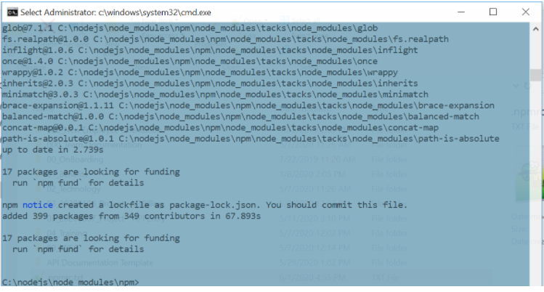  If the "npm" Command resulted in failure, install dependencies manually by executing following commands:  - "npm install express -g"  - "npm install url -g"  - "npm install fresh -g"  - "npm install cookie -g"  - "npm install methods -g"  - "npm install crc -g"  - "npm install send -g"  - "npm install connect -g"  - "npm install commander -g"  ***For additional Reference***  https://coderwall.com/p/mbov6w/running-nodejs-and-express-on-windows
15 | Install Nodeclipse CLI, Express, & Express Generator Package Dependencies | Type the following global statements at the "Node.js" Command Line and hit the ENTER Key.  a. npm install -g nodeclipse  b. npm install -g express  c. npm install -g express-generator  These are dependencies for the Eclipse IDE Nodeclipse Plugin mentioned later.
16 | OPTIONAL: Additional Package Installs specific to Microsoft .NET and Visual Studios IDE's  npm install --global windows-build-tools | Installing the "Windows-build-tools" Packages Globally, will allow the developer to install Microsoft Windows Build Tools specific to the .NET World. It will also install Microsoft Visual C++ Build Tools that caters towards the Microsoft Visual Studios IDE,.  All being required to Compile Native Node.js Modules.  It will also install Python Ver 2.7, configuring the developer machine and "npm" accordingly to allow the developer to leverage "node-gyp". "Node.js" Build Utilities  This is not a requirement for this effort, because we will not alter/create/update Node.JS Modules nor are we developing within a Client-side Framework, like React JS. Also all development will be performed in JAVA 8, not Node.js.
17 | Download JAVA | Allstate Approved Version JAVA Version 8.0 +, can be found at Oracle's site; https://www.oracle.com/java/technologies/javase-jdk8-downloads.html  I chose to download the Windows 64 bit Version as an EXE File, "jdk-8u251-windows-x64.exe".  ***It is critical that Step 1 was accomplished first in order to run this EXE File***  JAVA Platform Standard Edition 8 Documentation: https://docs.oracle.com/javase/8/docs/
18 | Right-Click on the jdk-8u251-windows-x64.exe Executable File and "Run Elevated with DefendPoint" | This will walk through a typical windows install process. The only nuance that I chose to update the install path to "C:\Java" from the default. "C:\Program Files (x86)\Java\jre1.8.0_251". Run this to successful completion.
19 | Create/Update the JAVA_HOME System Environment Variable | Validate/Configure the JAVA_HOME System Environment Variable Path has been set to the destination folder where the Java was installed to. Currently 1.8.251 is installed on my machine.  Presently the JAVA_HOME System Environment Variable has been configured with an "AdoptOpenJDK" Declaration. May not have to update the System Environment Variable after all. Will require further research as to how this compares to the Oracle Version just downloaded. At this point perform any level of cleanup that may have System Environment Variables pointing at previously leveraged JDK/JRE's...  This is the current value for the JAVA_HOME System Environment Variable: "C:\Program Files\AdoptOpenJDK\jdk-8.0.232.09-hotspot\"
20 | Download Eclipse Luna Integrated Development Environment (IDE) | As before, download the 64 bit version; https://www.eclipse.org/luna/
21 | Right-Click on the eclipse-inst-win64.exe Executable File and "Run Elevated with DefendPoint" | When the Eclipse Installer Window appears select the following: "Eclispe IDE for JAVA Developers"  The following installation settings were selected:  a. Java 1.8+ VM: "C:\Program Files\AdoptOpenJDK\jre-8.0.232.09-hotspot(current)"  b. Installation Folder: "C:\Eclipse_Luna" from the default. "C:\Users\mjojg\eclipse\java-2020-03".  Run this to successful completion.  c. Accept the License Agreement  Once complete it will offer the following options:  a. Launch  b. Show README File  c. Open in System Explorer  d. Keep Installer  I chose to Launch the IDE to continue with the configuration process.
22 | Validate that the Eclipse IDE, JAVA Compiler and Installed JRE's are configured to Step #'s 5 & 6 | Proceed to the following IDE Navigation:  Windows → Preferences → JAVA → Compiler  Windows → Preferences → JAVA → Installed JRE's
23 | Install Nodeclipse Eclipse Plugin  NOTE: Reference: the following link if necessary https://www.dev2qa.com/node-js-hello-world-example-with-eclipse/ | Navigate to the following:  Help → Eclipse Market  Type "Nodeclipse" within the Find Search Box  Hit the ENTER Key  The following will be returned, screenshot provided below. It will redirect the developer to a "Nodeclipse & Enide" Website; https://nodeclipse.github.io/  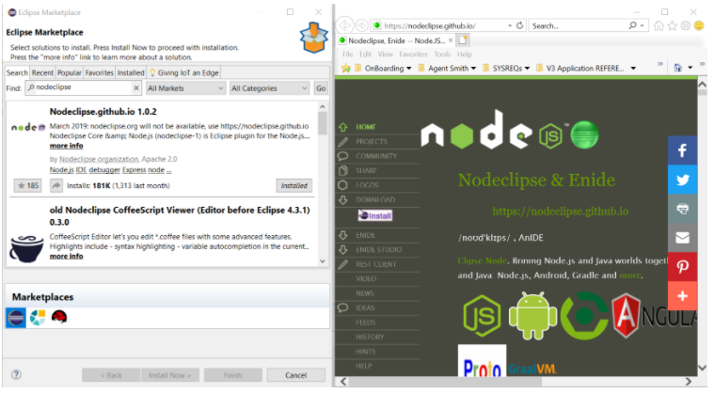
24 | Drag and Drop the "Nodeclipse & Enide" Eclipse Plugin into MarketPlace; | Eclipse will start the process of plugin install. Select all features as shown below and continue.  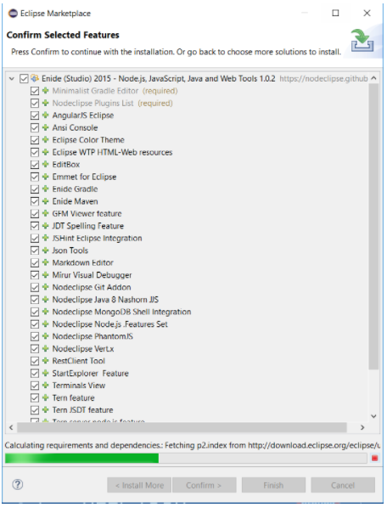
25 | Agree to the Install License | Agree to the Eclipse Plugin Install License and Continue
26 | Restart Eclipse | Restart Eclipse.
27 | Validate that Nodeclipse points at the newly installed version of "Node.js" Destination Folder (Reference Step #3) | Confirm Installed "Node.js" Destination Folder by performing the following navigation;  Window → Preferences → Nodeclipse  Reference Screen Shot Below.  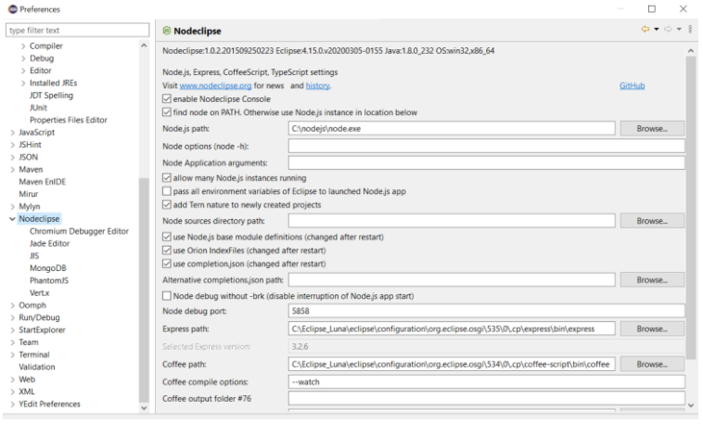
28 | Install Spring Tools Eclipse Plugin | Navigate to the following:  Help → Eclipse Market  Type "Spring Tools" within the Find Search Box  Hit the ENTER Key  Click the "Install" Button. (Reference the Screen-shot below for "Spring Tools 4 (aka Spring Tool Suite 4) 4.6.2 Release")  NOTE: Eclipse will start the process of plugin install. Select all features as shown below and continue.  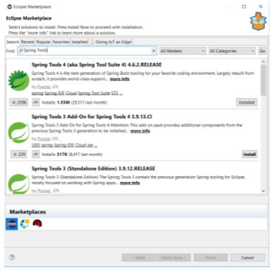
29 | Agree to the Install License | Agree to the Eclipse Plugin Install License and Continue
30 | Restart Eclipse | Restart Eclipse.
31 | Install GitHub.  NOTE: There are two options to install GIT. One is a Command Line Utility that I have personally chosen to download; whereas the other is a Desktop version of the application.  If a previous version exists on your system, please uninstall before proceeding. | GitHub Command Line Utility: https://git-scm.com/book/en/v2/Getting-Started-Installing-Git  Installing on Windows  There are also a few ways to install Git on Windows. The most official build is available for download on the Git website. Just go to https://git-scm.com/download/win and the download will start automatically. Note that this is a project called Git for Windows, which is separate from Git itself; for more information on it, go to https://gitforwindows.org.  Download the Windows 64 bit Version as an EXE File.  ***It is critical that Step 1 was accomplished first in order to run this EXE File***  ------------------------------------------------------------------------------------------------------------------  GitHub Desktop APP can be found at the following link: https://desktop.github.com/  Download the Windows 64 bit Version as an EXE File.  ***It is critical that Step 1 was accomplished first in order to run this EXE File***
32 | Right-Click on the Git-2.27.0-64-bit.exe File and "Run Elevated with DefendPoint" | This will walk through a typical windows install process. If a previous version exists on your system, UNINSTALL it before proceeding.  I have chosen to install to the destination folder, C:\Git, instead of the default. "C:\Program Files\Git". Run this to successful completion.  Once successfully completed you may Click the "Next" Button  It will redirect you to the Release Notes: file:///C:/Git/ReleaseNotes.html
33 | Navigate to the following : Start → Programs → Git. | Right Click on Git Bash and Open File Location
34 | Create Shortcut on Desktop for GitBash Command Prompt | File Explorer Window will Open. Right-Click on "Git Bash" and navigate to; Send To → Desktop(Create Shortcut
35 | Copy the KeyStore Certificate cacerts File out to your local JRE | Reference the following Keystore Certificate Project; https://github.allstate.com/Compozed/java-bp-cacerts  From this project, simply copy the cacerts file to your systems JAVA JRE system folder path. It has also been provided here for reference.  Make certain to backup the previous one prior to copying out the new certificate file.  Reference the "cacerts_Backup" as an example ( Mine has been provided as an example and a screen shot follows);  C:\Program Files\AdoptOpenJDK\jre-8.0.232.09-hotspot\lib\security  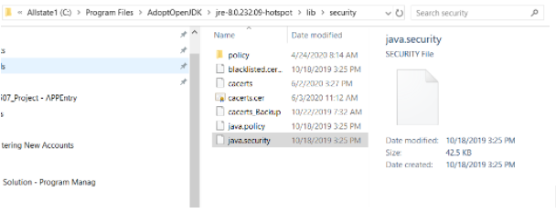
36 | Prepare to configure Git andor GitHub for a Corporate Web Proxy | Based upon the project mentioned in Step #32, https://github.allstate.com/Compozed/java-bp-cacerts, the Keystore Certificate File, cacerts was then leveraged as a base to generate a Bundled certificate file "ca-bundle.crt"  This Bundled Certificate File is what will be used to configure the Git and GitHub Web Proxy Settings. Both Bundled Files have been provided below.  For your reference what follows are the steps to create the Bundled Certificate File.  Within the "certmgr" utility at the command line.  It provides the means of importing the "cacerts" keystore file, only to then export it as a Base64 Encoded Format and append it to the "ca-bundle.crt" File.  Also, from Google Chrome navigate to Allstate's GitHub Website, https://github.allstate.com/ and export the certificate only to repeat the process mentioned previously to append it to the "ca-bundle.crt" File.  Within Google Chrome:  a. Click on the menu (⋮) displayed on the top right corner after the browser address bar  b. Now follow More tools >> Developer Tools.  c. Select the Security tab, a second right option with default settings. Click on View Certificate and go to the “Details” you will have certificate details  For the Git Command Line Utility copy both bundles out to the following system folder path (Remember this is specific to my machine and where I installed the Git Command Line Utility);  C:\Git\usr\ssl\certs  For the GitHub Desktop Application copy both bundles out to the following system folder path (Remember this is specific to my machine, my user, mjojg, you will have to alter this to your user path);  C:\Users\mjojg\AppData\Local\GitHubDesktop\app-2.5.2\resources\app\git\usr\ssl\certs
37 | Right-Click on the newly created Desktop Shortcut GitBash and "Run Elevated with DefendPoint"  ***It is a always good practice to run applications as "Run Elevated with DefendPoint" | Should open a GitBash Terminal
38 | Configure Git for your profile | Let's make sure that you have git installed and perform the initial configuration. Don't forget to substitute my name, email, and project with your values.  Reference, https://chronicler.tech/windows-password-manager-and-git/, for further information.  Execute the following GitBash Statements. Hit the ENTER Key after each statement  a. git --version  b. git version 2.27.0.windows.1  c. git config --global user.email insertEmailAddressHere  d. git config --global user.name "insertFirstLastNameHere"
39 | Configure Git for the Corporate Web Proxy | Execute the following GitBash Statements. Hit the ENTER Key after each statement.  If using the Git Command Line Utility Perform Steps a & b, this will allow you to enter your credentials upon using Git. For further information please reference the following; https://chronicler.tech/windows-password-manager-and-git/  Please note this will be specific to your user, so please replace 'DOMAIN\\mjojg' with your username.  a. git config --global http.proxy http://DOMAIN\\mjojg@github.allstate.com  b. git config --global https.proxy http://DOMAIN\\mjojg@github.allstate.com  If using the GitHub Desktop Application Perform Steps c & d, this will clear the proxy settings  c. git config --global http.proxy ""  d. git config --global https.proxy ""  Perform the remaining Steps e & f  e. git config --global http.sslverify false  f. git config --global http.sslCAInfo C:/Git/usr/ssl/certs/ca-bundle.crt  I chose to use the GitHub Desktop Application, so when finished your .gitconfig file, located at your User System Folder path, mine has been provide for reference; C:\Users\mjojg, should resemble the following(Attached below);
40 | Install Gradle | Reference the following link for downloads: https://gradle.org/install/  Microsoft Windows users  Create a new directory C:\Gradle with File Explorer.  Open a second File Explorer window and go to the directory where the Gradle distribution was downloaded.  Double-click the ZIP archive to expose the content.  Drag the content folder gradle-6.5 to your newly created C:\Gradle folder.
41 | Update System Environment Variable "PATH" | Update the System Environment Variable "PATH" with the following "C:\Gradle\gradle-6.5\bin"
42 | Validate successful installation | Right-Click on the Command Prompt Desktop Shortcut and "Run Elevated with DefendPoint"  Execute the following statement:  a. gradle -v  If successful, should return the following:  ------------------------------------------------------------  Picked up _JAVA_OPTIONS: -Xmx6144m  Welcome to Gradle 6.5!  Here are the highlights of this release:  - Experimental file-system watching  - Improved version ordering  - New samples  For more details see https://docs.gradle.org/6.5/release-notes.html  ------------------------------------------------------------  Gradle 6.5  ------------------------------------------------------------  Build time: 2020-06-02 20:46:21 UTC  Revision: a27f41e4ae5e8a41ab9b19f8dd6d86d7b384dad4  Kotlin: 1.3.72  Groovy: 2.5.11  Ant: Apache Ant(TM) version 1.10.7 compiled on September 1 2019  JVM: 1.8.0_232 ( 25.232-b09)  OS: Windows 10 10.0 amd64
43 | Close out all applications and restart your computer
 | Congrats!!! You are now ready to Create a New Project or Import an Existing One.

